PAPER EVALUATION USING ARTIFICIAL INTELLIGENCE (HYBRID AI FRAMEWORK FOR RESEARCH PAPER EVALUATION AND REVIEWER RECOMMENDATION)
Methodology, Novelty and Key Contributions
Department of Computer Science and Engineering, TKR College of Engineering & Technology
Batch C8 (CSE-C) · Academic year [ACADEMIC YEAR]
Table 1: Project team
S.No. | Student name | Roll number
1 | Mula Sreebindu | 23K91A05G3
2 | Puramshetty Vishnu Vardhan | 23K91A05K2
3 | K Sampoorna | 24K95A0512
4 | Korsa Shivashankar | 24K95A0515

Project guide: M Anupama
Chapter and section numbers quoted in the text (for example Chapter 8 or Section 6.2) refer to the full project report, 17.Final Document. Figures and tables in this document are numbered from 1.

1. METHODOLOGY
This document describes how PeerScope works from end to end and what is new in it. Part 1 gives the pipeline, the data, the algorithms and the reasons they were chosen; Part 2 sets the work against the base paper and separates what is new from what is standard; Part 3 lists the contributions.

1.1 Overall methodology
PeerScope follows a hybrid method: deterministic text processing, one trained statistical classifier, a local language model used only to draft review text, and an embedding-based matching stage whose score can be audited term by term. The method has two outputs for every uploaded paper: a preliminary assessment (structural signals, a historical decision signal, a reviewer-style critique and related literature) and a ranked list of reviewers with the arithmetic behind every rank. The design follows the principle of auditable matching stated in the base paper [1], but the project's scope is broader (it adds the assessment of the paper) and its scale is much smaller (Chapter 8 states the differences). The steps are:
1. Upload and validate a PDF (extension, content type, size at most 20 MB, %PDF header).
2. Extract page text with PyMuPDF, normalise whitespace, guess the title, detect up to nine sections and parse the reference list.
3. Derive features: frequency keywords, method terms from a 21-term lexicon, topic hints from an 18-term list, and four structural signals combined into one structural score.
4. Classify the opening text with the trained TF-IDF + logistic-regression model to give a historical decision signal (accept / borderline / reject) with class probabilities.
5. Review: always produce the deterministic rule-based review; when the local Qwen2.5 model loads, add a three-step analyse, critique and synthesise pass; otherwise say plainly that it is unavailable.
6. Ground the paper in literature by querying OpenAlex with the title and ranking the six returned works by embedding similarity.
7. Match the paper profile against every reviewer profile: embedding cosine, keyword overlap, method and topic overlap, availability and a conflict penalty, combined with fixed, documented weights.
8. Store and export the result in SQLite and offer it as JSON or as a PDF report.
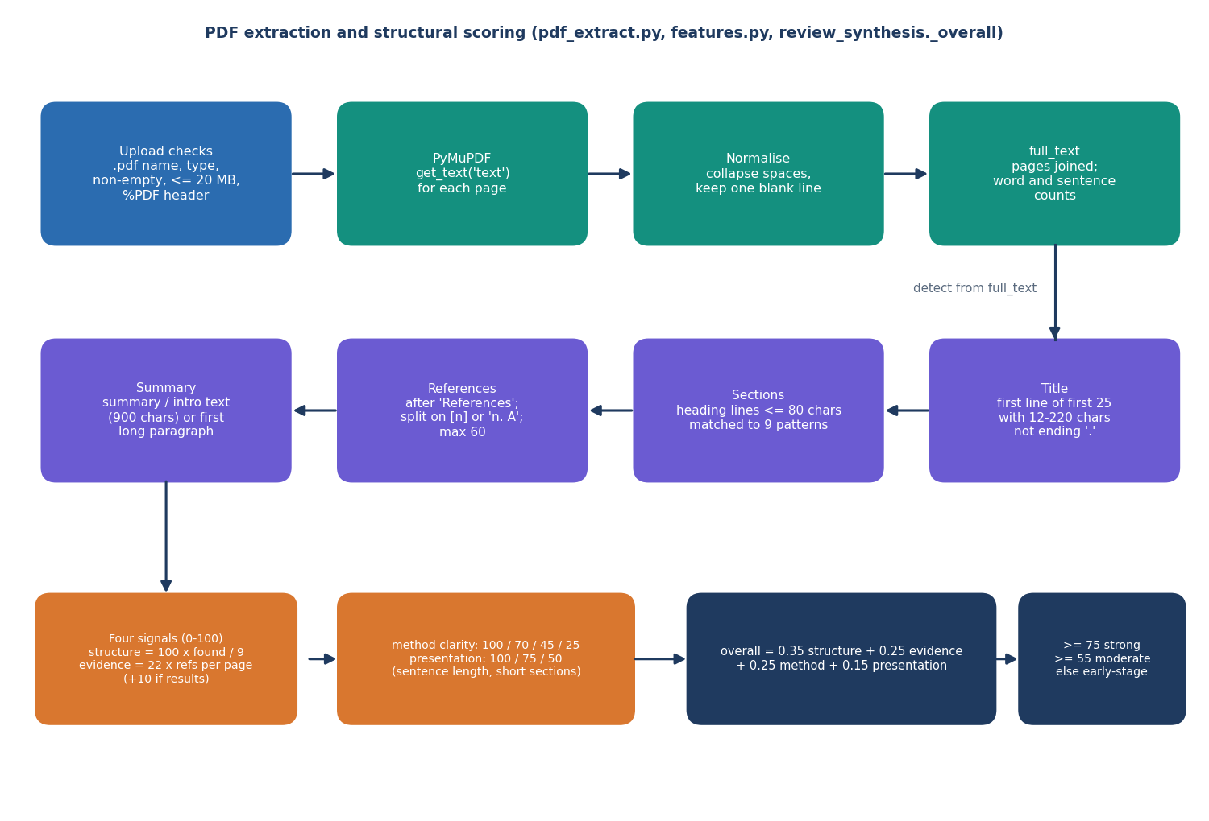
Figure 1: Text extraction, section detection and structural scoring of an uploaded paper.
Two further procedures sit outside the request path. The training pipeline builds the decision model once from a labelled CSV file and writes the model, the vectoriser and a metrics file; the evaluation scripts in this project (scripts/measure_metrics.py, scripts/measure_latency.py) re-evaluate the shipped model, run baselines and five further splits, and score the reviewer matcher on a probe set. Their output is the single source for every number in this report.

1.2 Datasets

1.2.1 Decision-model data: a synthetic corpus
The project looked for a public corpus of papers with reviewer decisions. The preparation script (scripts/prepare_dataset.py) probes one PeerRead-style file on a public repository [22] with a six-second timeout and, because no usable data came back, falls back to a generated corpus. The shipped model is therefore trained on 1,400 synthetic rows; models/metrics.json records dataset_source: synthetic-fallback and the web application shows a visible warning beside every metric. This is the most important limitation of the decision model and the rest of this section explains exactly what the data can and cannot show.
Each row is made by a seeded random generator (seed 42). One of six topics is drawn (vision, language, learning, systems, security, data), each with seven topic words, and a latent quality value q is drawn uniformly from 0 to 1. If q is above 0.52 the paper is given three of seven strength phrases (for example "strong baselines", "comprehensive ablations"); otherwise it is given three of seven weakness phrases (for example "missing baselines", "unsupported claims"). The label is accept when q > 0.72, reject when q < 0.30 and borderline otherwise, which includes both the upper-middle strength papers (0.52 < q <= 0.72) and the lower-middle weakness papers (0.30 <= q <= 0.52). A title and a short template paragraph containing the phrases and topic words form the text. The resulting class counts are accept 362, borderline 619 and reject 419.
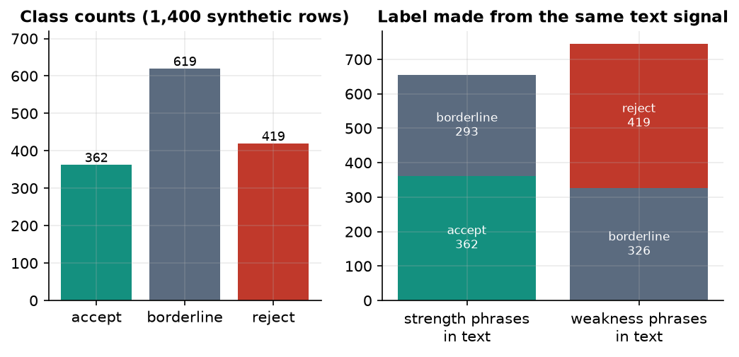
Figure 2: Class counts of the synthetic corpus and how the label relates to the text signal that the classifier can see.
The right-hand panel shows why the data are limited. Of the 655 papers that contain strength phrases, 362 are labelled accept and 293 borderline; of the 745 papers with weakness phrases, 419 are reject and 326 borderline. The borderline class is generated from both phrase groups, so the text alone cannot separate it from accept or reject. A rule that reads the phrases and always answers accept or reject reaches only 55.8% accuracy on the whole corpus, and no text classifier can do better than about 55.8%. Accuracy near 0.55 is therefore what the data allow, not a sign of a weak method; equally, it says nothing about real peer-review decisions.
The corpus is split 80/20 with a stratified split and seed 42 into 1,120 training and 280 test rows.

1.2.2 Reviewer data
The reviewer directory is seeded at first start with 6 clearly labelled demo profiles (Reviewer Alpha to Reviewer Zeta; Epsilon is inactive). Each profile has a display name, affiliation, free-text expertise description, comma-separated research topics, methods and keywords, publication titles, a current and a maximum review load, an active flag and comma-separated conflict terms. The areas are computer vision, language processing, applied machine learning and reproducibility, network security, medical informatics and robotics. The directory can be extended by form or by CSV import. No real person's publication history is stored, and no h-index is computed; the project abstract mentions publication history, and the closest implemented element is the publication_titles text field.

1.2.3 Probe set for the matching evaluation
To measure the matcher without real submissions the team wrote 40 short abstracts (scripts/eval_data.py): six for each of the six reviewer areas and four deliberately cross-area papers for which two reviewers are acceptable. The abstracts avoid copying the reviewers' keyword lists. A second list of 15 conflict cases adds one sentence to a paper that links it to a reviewer by a conflict term (6), an affiliation string (4), the reviewer's full name (2), a reworded affiliation (2) or a first name alone (1). The labels are the team's own judgement. They are not independent expert judgements, so the matching results in Chapter 8 are optimistic and are a check of the mechanism, not a validation on real submissions.

1.2.4 Real documents used for observation
Four real PDFs were run through the extraction, feature and decision stages to observe behaviour on genuine papers: the generated demo paper (3 pages) and three research PDFs kept with the batch (30, 17 and 30 pages). They are not labelled and therefore support no accuracy claim.

1.3 Extraction and preprocessing
All extraction is local and deterministic (app/services/pdf_extract.py). The steps, in order:
Table 2: Extraction steps and the reason for each
Step | Operation | Reason
1. Page text | page.get_text('text') for every page with PyMuPDF; text of each page is kept with its page number | Local, fast and layout-preserving; page numbers let the review point to evidence
2. Normalise | Collapse tabs and spaces, drop repeated blank lines, keep paragraph breaks | Makes sentence and section statistics stable
3. Title | First line among the first 25 that is 12-220 characters and does not end with a full stop | Cheap heuristic; fails on papers whose first lines are identifiers (observed on the IEEE base paper)
4. Sections | Lines shorter than 81 characters matched against regular expressions for nine sections (summary, introduction, related work, methodology, experiments, results, discussion, conclusion, references); the text up to the next heading is the section body | Gives per-section word counts for the structural signals; fragile for roman-numeral headings
5. References | Text after a line References (or Bibliography) split at [n] or n. markers; fall back to bracketed lines | Reference count and density feed the evidence signal
6. Summary | Preview of the summary or introduction section, else the first paragraph longer than 120 characters (max 900 characters) | Short text for the classifier, the matcher and the literature query

Feature extraction (app/services/features.py) then computes word, sentence and reference statistics; the 15 most frequent non-stop-word tokens of three or more letters as keywords; the method terms (from a lexicon such as neural, transformer, regression, baseline, cross-validation, Bayesian) found in the text; and topic hints (vision, language, security, graph, medical and so on). These lists are simple on purpose: they are transparent, instant and easy to audit, and their weakness (no stemming, no phrase detection) is stated in Chapter 10.

1.4 Algorithm choice and justification
Table 3: Algorithms used and why they were chosen
Component | Choice | Reason | Alternative not chosen
Text features for the decision model | TF-IDF, word 1-2-grams (8,000) + character 3-5-grams (4,000) [17, 18] | Strong, fast, interpretable baseline for short text; trains in seconds on a CPU | Fine-tuned transformer: needs real labelled data and a GPU
Decision classifier | Multinomial logistic regression, class_weight=balanced [31] | Gives calibrated-looking class probabilities for the confidence display; convex, deterministic with a seed | Boosted trees / neural network: no gain was possible on data with this label structure
Expertise similarity | Sentence embeddings all-MiniLM-L6-v2, cosine [19, 20] | Same encoder family as the base paper's bi-encoder baseline; 384 dimensions; runs on a CPU | SPECTER [21]: larger and not needed for the small pool; LLM keyword ensembles of the base paper: costly
Lexical evidence | Keyword overlap and method / topic overlap (exact and substring hits) | Gives the human-readable matching terms shown beside each rank | Embeddings alone cannot name what matched
Availability and conflict | Load ratio and literal-string conflict penalty inside the score | Makes workload and conflicts visible in the same audit table | External assignment solver: out of scope
Review drafting | Qwen2.5-1.5B-Instruct (fallback 0.5B), CPU, greedy decoding [29, 30] | Open weights, runs locally so no manuscript leaves the machine; small enough for 16 GB RAM | Hosted LLM: would send unpublished manuscripts to a third party
Literature context | OpenAlex works search [32] | Free, no key, open index | Paid APIs

The central design choice is separation of roles. The trained classifier gives one weak signal; the structural signals are deterministic; the language model writes prose but never ranks reviewers or changes a score; and the matching score is arithmetic that a reader can recompute from the audit table. This separation answers the concern that dense-embedding matchers are hard to audit [1] and the evidence that LLM reviewers can be steered by hidden text in a manuscript [2, 27]: the model's text is displayed as an aid and never feeds a number.
Two inexpensive improvements were considered and left for future work because they need real data to justify: learning the matching weights from historical assignments (the base paper's data of this kind is not available to the project), and replacing the keyword lists with an LLM keyword ensemble.

1.4.1 Deterministic review rules
The review that is always produced (review_synthesis.deterministic_review) is a set of explicit rules over the extracted features, so that every sentence can be traced to a number. Strengths are added when a methodology section exists (with its word count), when an experiments or results section exists, when at least eight references are found and when at least five sections are recognised. Major concerns are raised when no methodology section is found or it has fewer than 120 words, when no experiments or results section is found, when fewer than five references are found and when the mean sentence length exceeds 32 words. Minor concerns cover short sections, each missing section, a title shorter than 20 characters and an opening summary shorter than 200 characters. Five generic recommendations (state the contribution early, document reproducibility details, add ablations, discuss threats to validity, proofread) are always listed. A six-axis coverage object (method, evidence, clarity, reproducibility, novelty, limitations) is computed from the same features for the radar chart; the novelty axis is a fixed value of 55 because novelty cannot be measured from one paper, and the accompanying text says that novelty is inconclusive and requires verification against the literature.

1.4.2 Local language-model review
When the language model loads, llm_review runs three prompts on the first 6,000 characters of the paper. The analyse prompt asks for the problem, contribution, approach, set-up, claims, evidence, strengths, weaknesses and missing information; the critique prompt asks for a critique of method clarity, evidence, completeness, reproducibility, limitations and consistency, with cautious wording such as novelty signal and requires verification; the synthesise prompt combines both into a structured assessment with ten headings. The system prompts forbid inventing experiments, data or citations. Generation is greedy (no sampling) with budgets of 512, 512 and 700 new tokens. If the model cannot be loaded the review carries llm_status: unavailable and the reason; if generation fails it carries error. In both cases the deterministic review is shown unchanged. The model is loaded once, on the first analysis, under a lock, with the 0.5B model as a fallback if the 1.5B model cannot be loaded.

1.4.3 Conflict-of-interest detection
detect_conflict lower-cases the first 3,000 characters of the paper text and tests three things: any comma-separated conflict term of the reviewer, the reviewer's full display name, and the full affiliation string (longer than four characters). A match sets the conflict flag, adds the penalty and replaces the explanation with the reason (for example Conflict term match: ...). The method is exact and therefore predictable, which suits an audit, but it cannot recognise a reworded affiliation, a first name alone, co-authorship or a citation relationship; these limits are measured in Chapter 8 and listed in Chapter 10.

1.4.4 Literature grounding and embeddings
The OpenAlex query uses the extracted title (or the first six keywords), asks for six works and selects identifier, title, year, authors, source and DOI. The works are re-ranked by the cosine between the query and each title in the embedding space, with a word-overlap fallback if embeddings are unavailable. Any network error returns literature_retrieval_status: unavailable and an error text. Embeddings come from all-MiniLM-L6-v2 (inputs truncated to 2,000 characters). If it cannot be loaded, a TF-IDF vectoriser with at most 512 features and 1-2-grams is fitted on the first batch of texts it receives and then reused unchanged; the consequence, that the vocabulary is frozen by the first request, explains the lower matching accuracy of the offline mode reported in Chapter 8 (top-1 0.75 against 0.95).

1.4.5 Decision signal at inference time
For an uploaded paper the classifier receives the extracted title, the paper summary and the first 4,000 characters of the full text, vectorised with the training vectorisers. The service returns the label with the highest probability, that probability as the confidence, all three probabilities and a fixed note that the signal is learned from prior review records and is not a judgement of correctness. If the artifacts are missing it returns model_unavailable instead of a guess.

1.5 Mathematical formulation

1.5.1 Text representation and classifier
With N training documents, a term t that occurs in df(t) of them and a raw count tf(t, d), the TF-IDF weight (scikit-learn's smoothed form) is
x(t,d) = tf(t,d) × [ ln((1 + N) / (1 + df(t))) + 1 ] (each vector then scaled to unit Euclidean length) (1)
The word and character vectors are concatenated into one 12,000-dimensional sparse vector x. For K = 3 classes the multinomial logistic model gives
P(y = k | x) = exp(wₖ·x + bₖ) / Σⱼ exp(wⱼ·x + bⱼ) (2)
and is fitted by minimising the class-weighted regularised log-loss
L(W, b) = − Σᵢ ωᵧᵢ · ln P(yᵢ | xᵢ) + (1 / 2C) · ‖W‖², ωₖ = n / (K · nₖ), C = 1 (3)
where nₖ is the number of training documents in class k; the weights ωₖ increase the influence of rarer classes. The reported confidence of a prediction is the largest class probability. Macro precision, recall and F1 average the per-class values with equal weight; the multi-class ROC-AUC is the one-versus-rest average.

1.5.2 Reviewer matching
For a paper profile p and a reviewer profile r (text, keyword set, method set), the expertise similarity is the clipped cosine of their embeddings u and v:
sim(p, r) = max(0, u·v / (‖u‖ ‖v‖)) (4)
Keyword and method overlaps compare two term sets A and B by the number h of hits, where a hit is an exact match or a term contained in a term of the other set:
overlap(A, B) = min(1, 1.1 · h / max(|A|, |B|)) (0 if either set is empty) (5)
Availability falls linearly with the reviewer's current load, and the conflict flag c is 1 when a conflict term, the reviewer's full name or the affiliation string occurs in the first 3,000 characters of the paper text:
avail(r) = clip(1 − load(r) / max_load(r), 0, 1) (6)
The final match score, reported from 0 to 100, is the audited weighted sum (weights from app/config.py, adjustable by environment variables):
score(p, r) = 100 · clip( 0.55·sim + 0.20·kw + 0.15·method + 0.10·avail − 0.60·c , 0, 1 ) (7)
The labels Strong, Good, Possible and Weak correspond to scores of at least 65, 45, 25 and below 25. A conflict therefore subtracts 60 points, which in practice drives the reviewer to the bottom of the list while the breakdown still shows the other components.
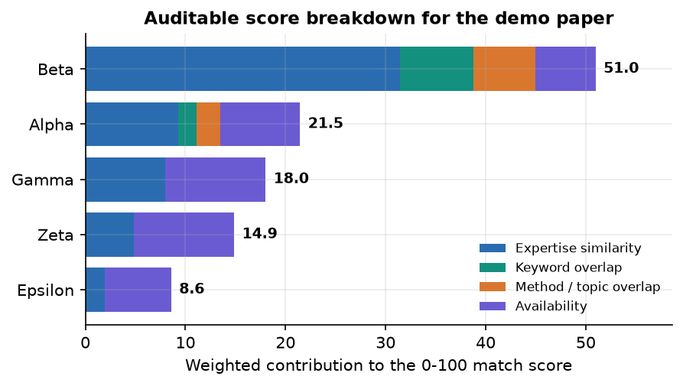
Figure 3: Weighted contribution of each component to the match score of the five best reviewers for the demo paper.

1.5.3 Structural score
Four signals in the range 0 to 100 are derived from the extracted document. With S the number of detected sections out of nine, R the number of references, G the page count, w̄ the mean sentence length in words and q the share of detected sections shorter than 40 words:
structure = 100·S/9; evidence = min(100, 22·R/G + 10·[experiments or results present]) (8)
method clarity = 100 if the methodology section has ≥ 120 words, 70 if it exists, 45 if method terms occur, else 25 (9)
presentation = 100 if 12 ≤ w̄ ≤ 26 and q < 40 %, 75 if 8 ≤ w̄ ≤ 32, else 50 (10)
structural score = 0.35·structure + 0.25·evidence + 0.25·method clarity + 0.15·presentation (11)
The weights and thresholds are design decisions chosen so that a complete, referenced paper scores high; they were not fitted to human judgements and the score is presented as one input among several. The overall wording (Strong, Moderate, Early-stage) uses cut-offs of 75 and 55.

1.6 Model training and configuration
scripts/train_model.py reads the CSV, joins title and text, encodes the labels alphabetically (accept, borderline, reject), splits 80/20 with a stratified split and seed 42, fits the two TF-IDF vectorisers on the training part only, fits the classifier and writes models/decision_model.joblib, models/tfidf_vectorizer.joblib and models/metrics.json.
Table 4: Training configuration
Item | Value
Rows / train / test | 1,400 / 1,120 / 280
Split | 80/20, stratified by label, random_state 42
Word TF-IDF | 1-2-grams, 8,000 features, English stop words removed, lower-cased
Character TF-IDF | char_wb 3-5-grams, 4,000 features
Classifier | LogisticRegression(max_iter=1000, class_weight='balanced', C=1.0, random_state=42)
Inference text | Title + summary + first 4,000 characters of the paper
Training time | Seconds on the CPU (measured step: all of decision_model evaluation, five re-fits and baselines took under 10 s)
Software | Python 3.11.9, scikit-learn 1.9.1, NumPy 2.4.6, pandas 3.0.6
Hardware | 12th Gen Intel(R) Core(TM) i5-12500, 15.7 GB RAM, none used (CPU only)

Re-loading the saved artifacts and scoring the same split reproduces the saved metrics.json exactly (accuracy 0.550, macro F1 0.509, ROC-AUC 0.771). The artifacts were written by scikit-learn 1.9.0 and loaded under 1.9.1; scikit-learn warns about the version difference, and a model pickled by an older release does not load reliably, which is why the model is retrained by run.bat on a new machine.
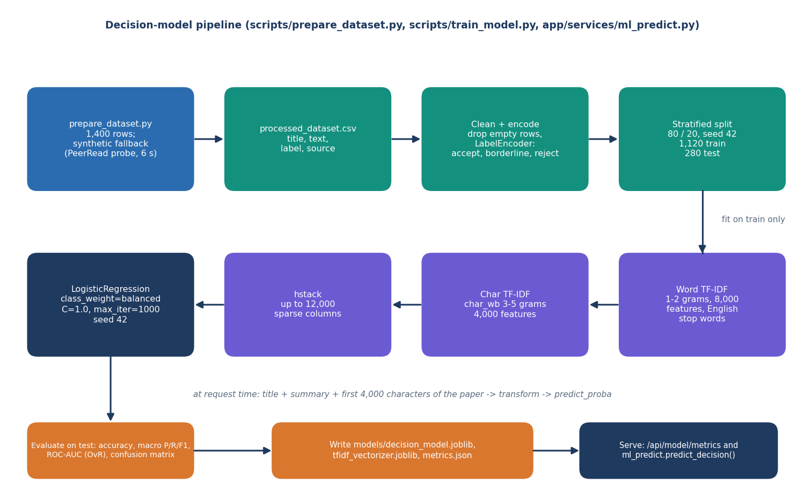
Figure 4: Training pipeline of the decision model.
Beyond the single run, the evaluation scripts re-fit the same configuration on five further stratified splits (seeds 0 to 4) and on three simpler baselines so that the accuracy can be put in context. Chapter 8 reports those results. No hyper-parameter search was run: on data whose labels are partly random by construction, tuning would only fit noise, and the unweighted and word-only variants tried as baselines performed within the spread of the seeds.

1.6.1 Evaluation protocol
The decision model is evaluated on the held-out 20 % only, once, with accuracy, macro precision, macro recall, macro F1, one-versus-rest ROC-AUC, the confusion matrix and per-class scores. Because the classifier outputs probabilities, a confidence-threshold analysis reports the share of papers kept and the accuracy on the kept papers for thresholds from 0.4 to 0.9. Three baselines on the same split put the result in context: the majority class, multinomial Naive Bayes on word TF-IDF, and the same logistic regression without class weights or without character features. A last check re-fits the shipped configuration on five different splits to show how much the numbers depend on the split.
The matcher is evaluated on the 40 probe papers against all six reviewers (inactive ones included, because the question is similarity, not eligibility). For each paper the rank of the best acceptable reviewer is found and three scores are reported: top-1 (the best acceptable reviewer is ranked first), top-3 (within the first three) and the mean reciprocal rank (the average of 1/rank). The same probe set is scored under four weight settings (shipped hybrid, semantic similarity only, lexical overlap only, hybrid without availability) and two embedding back-ends (MiniLM and the offline TF-IDF fallback), and a random ranking gives the reference level. Conflict handling is scored as the share of injected links that set the flag, with the number of false flags over all 240 clean paper-reviewer pairs as the complementary figure. Finally the ranking time is measured for pools of 6, 50, 200 and 500 reviewers.

2. NOVELTY AGAINST THE BASE PAPER
PeerScope does not propose a new learning algorithm or a new similarity measure, and we do not claim one. Its building blocks (TF-IDF, logistic regression, sentence embeddings, cosine similarity, an instruction-tuned language model, a public scholarly index) are standard. What is new is the combination, the way availability and conflict of interest are brought inside an auditable score, the delivery as a complete local application, and the care taken to measure the parts and to say where the measurement is weak. This section states the difference from the base paper first and then separates what is new from what is not.

2.1 Difference from the base paper
The base paper [1] studies the reviewer assignment problem. Its central idea is to restrict language models to inducing keywords, to choose among an ensemble's candidate lists with a judge model, to normalise the keywords deterministically and to store every intermediate artefact as an audit trail, so that a reviewer's score can be traced. It evaluates many matchers on 663 papers and 524 reviewer profiles with MRR@3, P@3 and MAP@3. It does not assess the submission itself and leaves conflict of interest and workload outside its experiments. The survey [6] and the other works of the literature chapter address automated review and decision prediction, but not reviewer assignment.
Table 5: PeerScope and the base paper compared
Dimension | Base paper [1] | PeerScope | What differs
Problem | Reviewer assignment: affinity between papers and reviewers | Preliminary paper assessment plus reviewer ranking in one tool | Both halves of the editorial workload in one application
Input | Titles, summaries and abstracts of 663 papers; up to 20 publications of each of 524 reviewers | An uploaded PDF (up to 20 MB) and six demo reviewer profiles | Raw PDF intake and text extraction; far smaller reviewer data
Keyword step | Ensemble of producer LLMs plus a judge LLM, then lemmatisation | Frequency keywords and fixed method and topic lists | No LLM in the ranking path; weaker, but deterministic and cheap
Similarity | TF-IDF, Jaccard, SBERT, cross-encoder, keyword graphs | all-MiniLM-L6-v2 cosine (TF-IDF fallback) plus keyword and method overlap | Same encoder family as the base paper's SBERT baseline; one fixed hybrid
Auditability | Stored prompts, model ids, candidate lists, score matrices | Per-recommendation breakdown of every weighted term, matched terms and an explanation | Shown in the interface, not only stored
Availability and conflict of interest | Left to a downstream solver; not benchmarked | Inside the score: load term and a 0.60 penalty | Measured only by an injection test
Paper assessment | None | Structural signals, decision signal, local-LLM critique, OpenAlex context | Not present in the base paper
Evaluation | 663 papers, 524 reviewers, historical assignments as labels, paired tests | 40 team-written probe abstracts, 6 demo reviewers, synthetic decision data | Far weaker; numbers are not comparable
Deliverable | Method and offline study | Runnable local web application with directory, history and export | A usable system around the method

The batch documents describe the project as reusing the base paper's technique. In fairness to the paper we state what was taken from it: the auditable principle (every recommendation can be explained from its parts) and the sentence encoder family. The keyword-induction ensemble, the judge, the keyword graphs and the statistical protocol were not reproduced.

2.2 What is standard and what is new
Table 6: Standard components and project-specific elements
Element | Standard or new | Comment
TF-IDF with logistic regression | Standard | Textbook text classification [17, 18, 31]
Sentence embeddings and cosine similarity | Standard | Pre-trained encoder used unchanged [19, 20]
Local instruction-tuned language model | Standard | Open-weight model loaded through a public library [29, 30]
OpenAlex retrieval | Standard | Public API [32]
Weighted score with itemised terms, availability and conflict penalty in one number | Project-specific | Brings workload and conflict into the same auditable breakdown; weights are unfitted
Visible fall-back for every optional component | Project-specific | The interface reports an unavailable model, literature service or decision artefact instead of hiding it
Structural signals from section detection and reference parsing | Project-specific | Transparent heuristics with documented weights; not validated against human judgement
Synthetic-data warning carried from the metrics file to the interface | Project-specific | The figures cannot be mistaken for a benchmark
Local-first processing with no account | Design choice | Manuscripts stay on the machine except title and keyword text sent to OpenAlex
Honest evaluation: baselines, five splits, label-ceiling analysis, probe set, injection test, stage timings | Project-specific | States which numbers are weak and why

3. KEY CONTRIBUTIONS
The key contributions, in the order in which the evidence supports them, are:
1. An end-to-end local application. One tool takes a research-paper PDF through extraction, assessment, literature context and reviewer matching, stores the result and exports it as JSON or PDF (1,449 lines of backend code, 6,926 lines of web interface, 7 automated tests and 24 end-to-end smoke checks, all passing).
2. An auditable matching score. Every recommendation shows the weighted terms of 0.55 expertise similarity, 0.20 keyword overlap, 0.15 method and topic overlap and 0.10 availability, minus a 0.60 conflict penalty, with matched terms and a plain-language explanation; on 40 probe abstracts the hybrid ranking puts an acceptable reviewer first in 95.0% of cases with sentence embeddings.
3. Availability and conflict of interest inside the score. All 12 of 12 literal conflict links injected into papers were flagged and none of 240 clean paper-reviewer pairs was flagged falsely; the 3 paraphrased links were missed, and this is reported.
4. A hybrid assessment with honest fall-backs. Structural signals, a trained decision signal and a local-LLM critique are combined, each reporting its own status; the offline TF-IDF fall-back reaches top-1 75.0% against the sentence-embedding result, and the interface says which one was used.
5. A frank account of the decision model. Accuracy 0.55 (macro F1 0.509) on a synthetic corpus whose labelling caps accuracy near 0.56, accept against reject separated 93% of the time, borderline almost never predicted, five-split mean 0.545 with a standard deviation of 0.028, and three baselines on the same split.
6. Measured cost of local AI. A stage-by-stage timing shows the local language model takes about 509 s of the roughly 534-946 s a full analysis needs on a CPU-only PC, whereas the deterministic path answers in about a second.
7. A reproducible evaluation kit. scripts/measure_metrics.py, scripts/measure_latency.py, the probe set and a verifier regenerate every number quoted in the documents.

